

Ajeevika SHG Individual App User Manual

|  |
| --- |
|  |
|  |
| SHG Enterprise App User Manual  By Kamtech Associates |

Contents

Section 1: General Information 3

1.1. Downloading Application (for demonstration purpose) 3

1.2. Opening Application 3

2.0. User, Accounts & Profile 4

2.1. Login & Logout 4

2.2. Forget Password 5

Section 2: Orders Status 6

2.1. Pending Orders 6

2.2. Received Orders 7

2.3. Delivered Orders 8

Section 3: Other features 9

3.1. Change Language 9

3.2. Grievances 10

# Section 1: General Information

Getting Started

## Application Overview

“Collection Center” is a web platform and android mobile app for the Collection Center which acts as a facilitator to receive products from Sellers and distribute to the buyers.

## Hardware and Software Requirements

* Requires a smart phone with Android operating system (OS) minimum Android version should be 9.0 and above.
* To download and use the functionalities of Ajeevika mobile app, you require an Internet connection in your mobile.
* An active email account.

## Purpose of the document

This document is aimed at serving as a guide for Collection Centers on the use of the

Ajeevika Mobile App. The document can also help the district/block admins and

government officials in understanding of the Collection Centre application.

## Downloading Application (for demonstration purpose)

Ajeevika application can be downloaded via Google Play Store. To download the application follow the following steps:

Step 1: Open Play Store application on your mobile by clicking on the Play Store icon as shown in the image below.

Step 2: Click on the Google Play text at the top and enter the text "Ajeevika" in the search bar. Click on the Ajeevika application icon from the search result.

Step 3: Click on the "INSTALL" button to install the application.

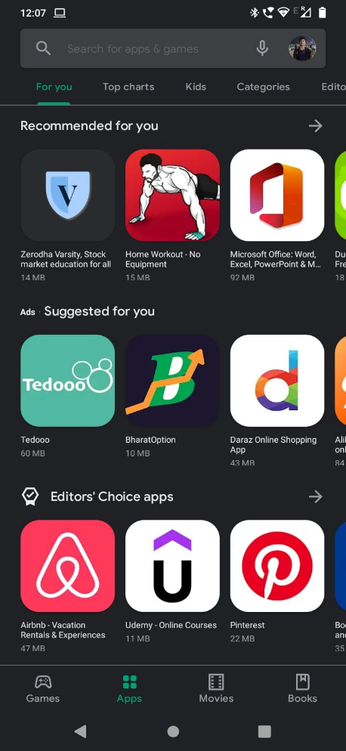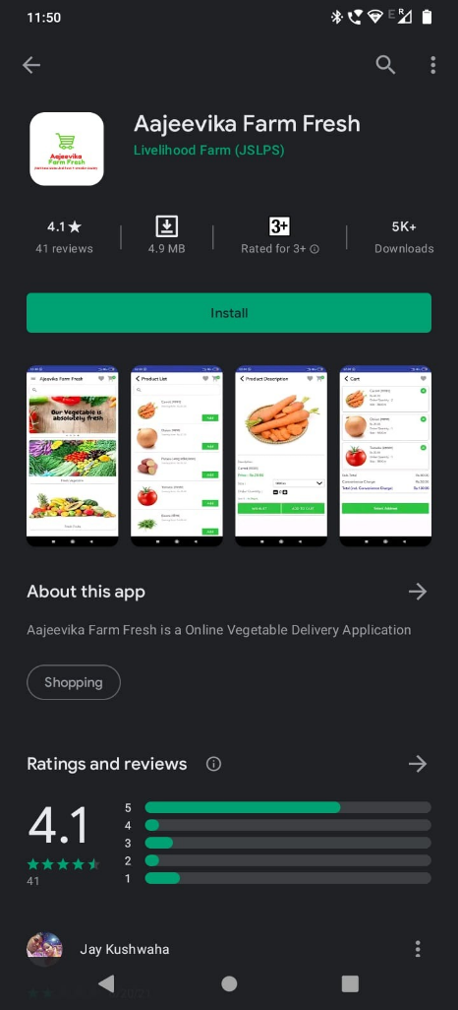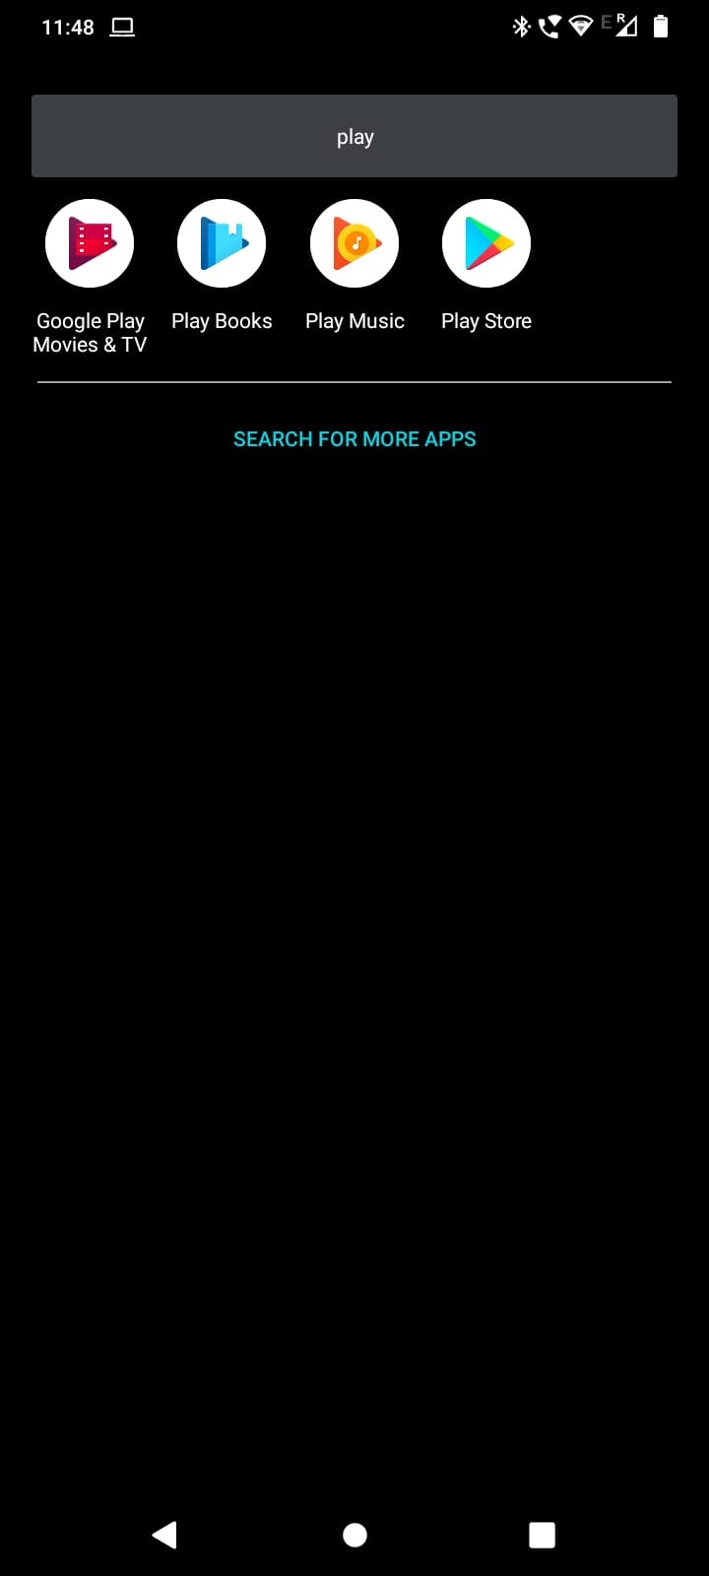

## Opening Application

Step 1: To find the application open your app drawer in android phone, and search “Ajeevika Seller”

Step 2: Click on “Collection” icon in the app drawer.

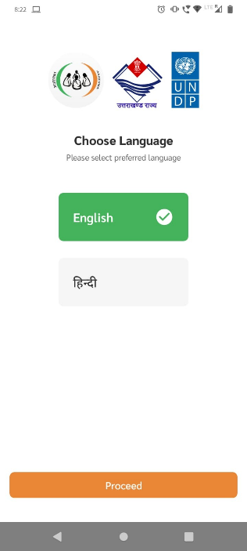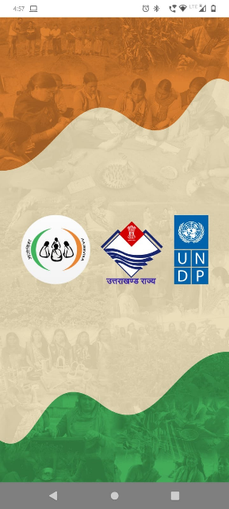Step 3: Choose the language of your choice.

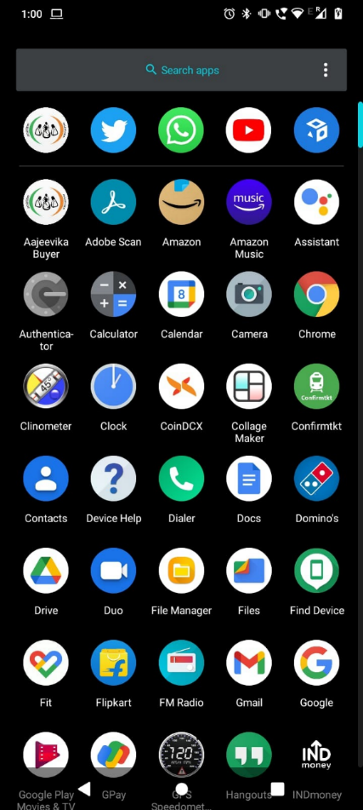

# User, Accounts & Profile

## Login & Logout

Once you create account you will be directly redirect into Home Page (which we will discuss below), but if you need to login/logout again follow the following steps:

Step 1: Open the application and enter your login credentials i.e email Id & password and click on Login button. You are successfully logged in.

Step 2: To logout click on menu button shown below, a side pane will pop up.

Step 3: Click on Logout button from the side pane.

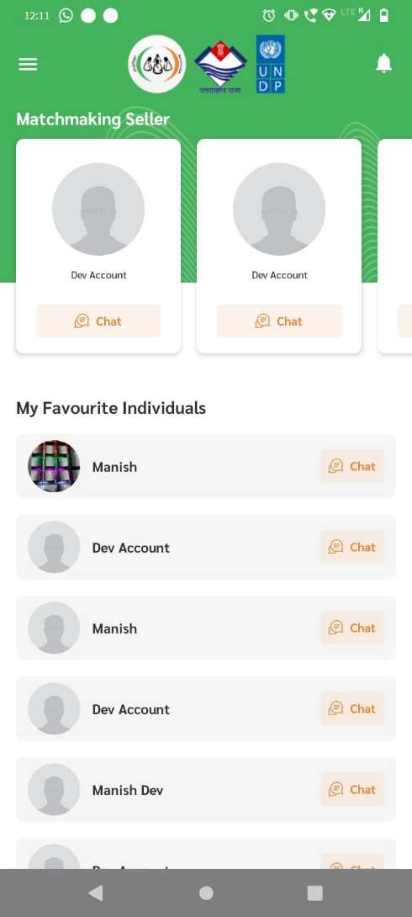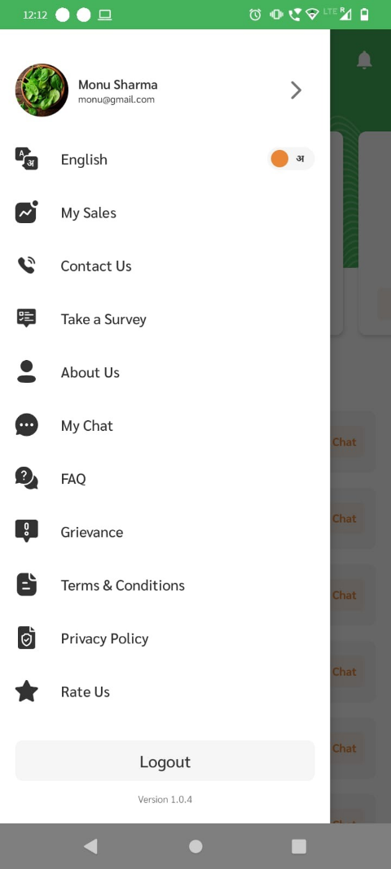

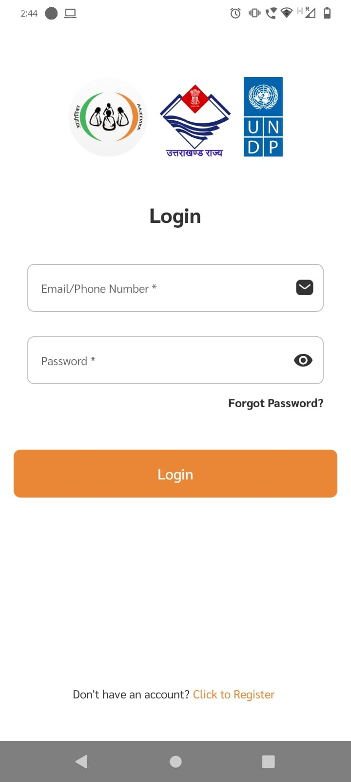

## Forget Password

If you forget your password, then don’t worry follow the following steps to change your password.

Step 1: Click on “forget password?” text shown below.

Step 2: Enter your registered mobile no. and click on Verify button

Step 3: Enter OTP received on your mobile no.

Step 4: Create new password and confirm your password and click on Save button.

Now you have successfully reset your password.

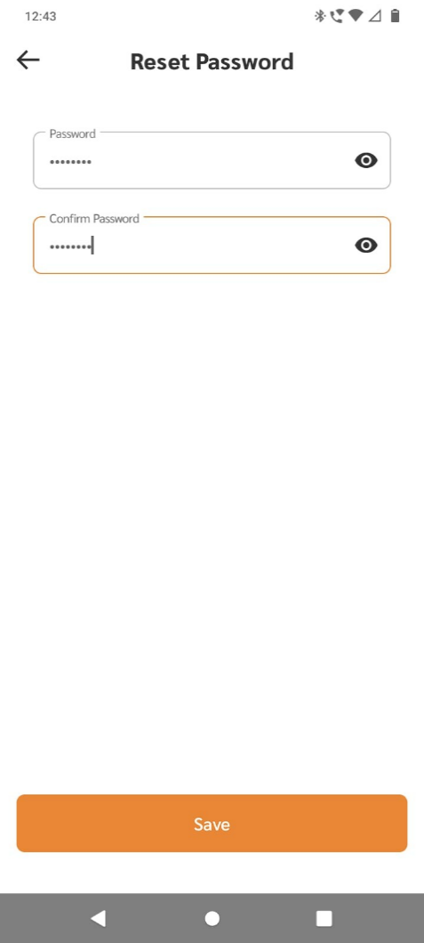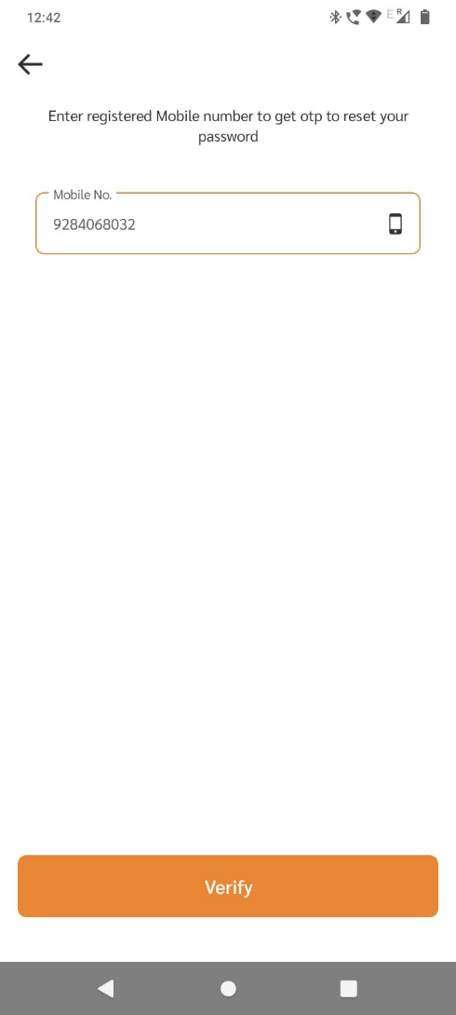

# Section 2: Orders Status

## Pending Orders

* These are the orders which have been marked by Seller with mode delivery as “Collection Center”. The order is shown in pending because the products for that particular order have not yet been delivered to the collection center.
* To view the order details click on green arrow corresponding to the product list.
* Here once the products of the corresponding order are received by the collection center, they can be marked as received. (“mark received” button)
* Once the product is marked received then rcpectiv buyer as well as seller gets notified.

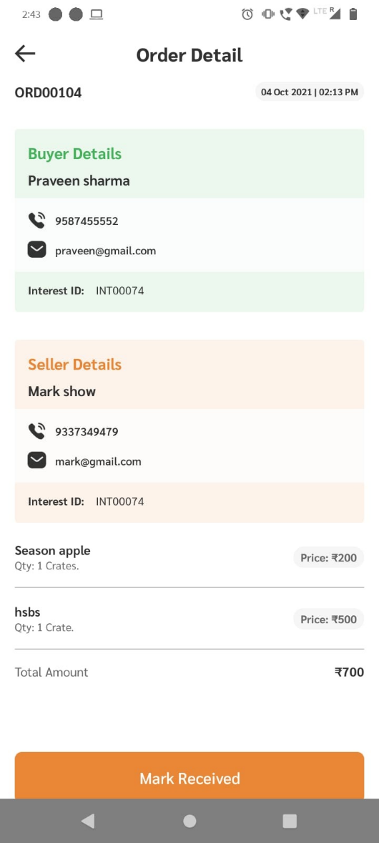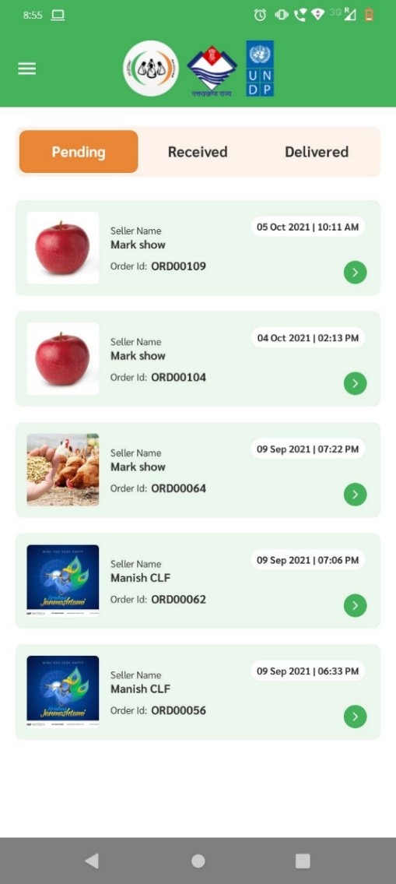

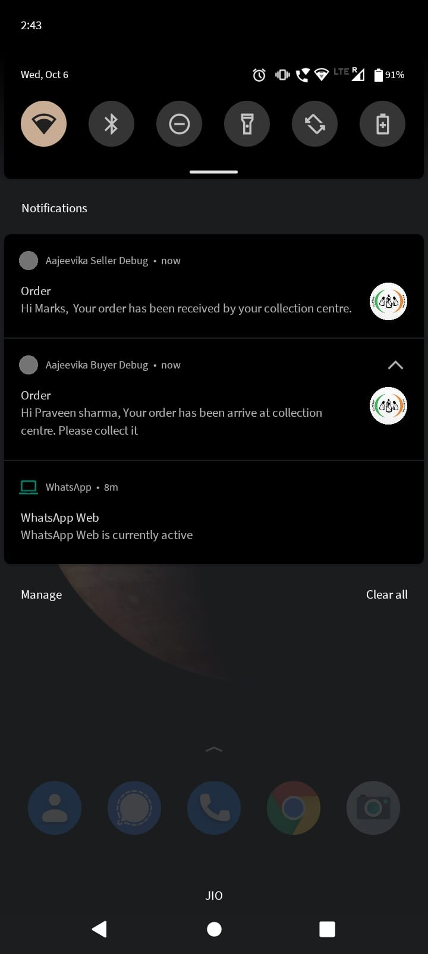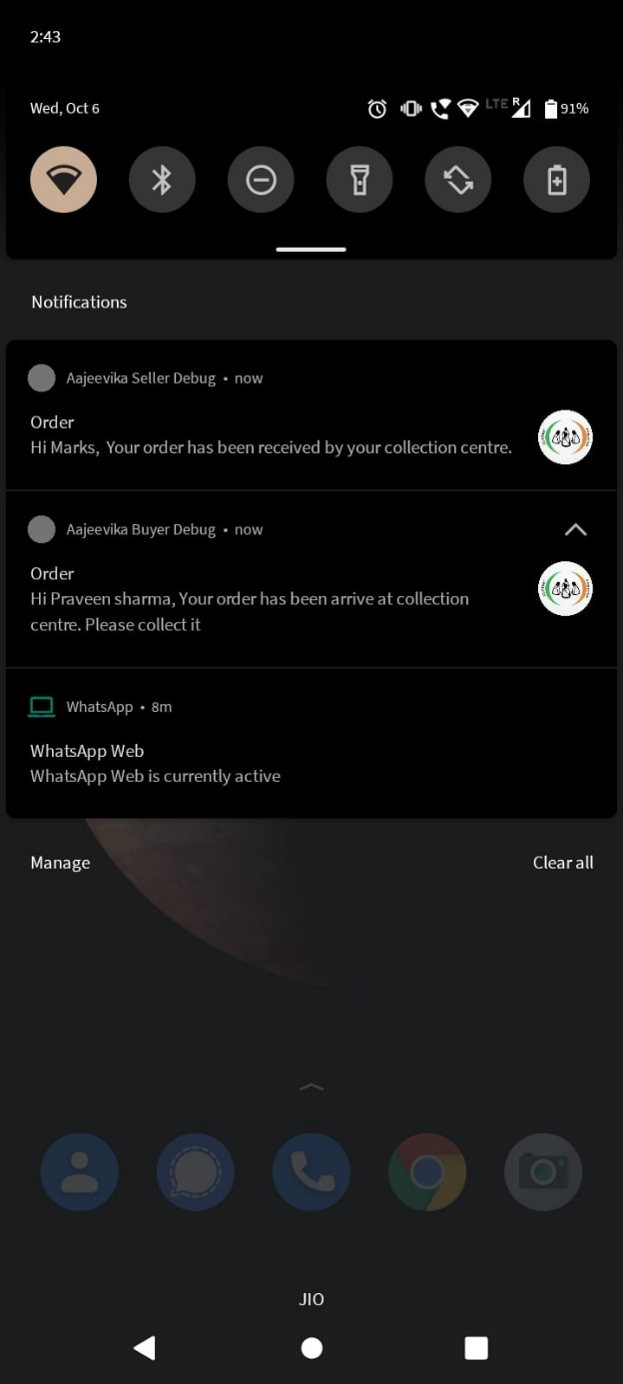

Notification to respective Seller

Notification to respective Buyer

## Received Orders

* These are the orders whose products are received by the collection center, and the buyer is notified for pick-up. Once the buyer is at the collection center to pick up his/her order, an OTP given by buyer has to be entered in the app and the order will be marked as delivered.
* Once the product marked as Delivered then respective seller as well as buyer will receive notification.

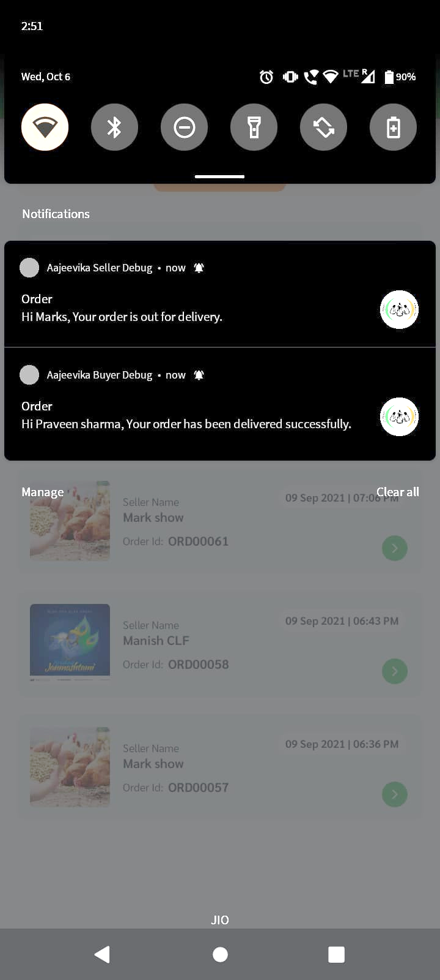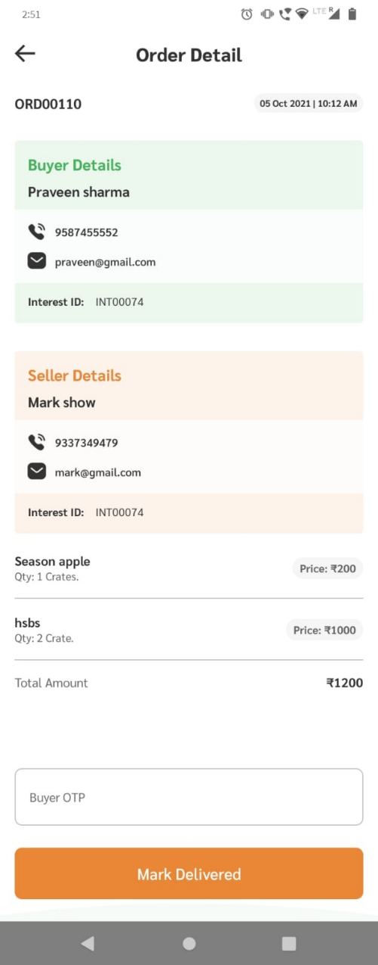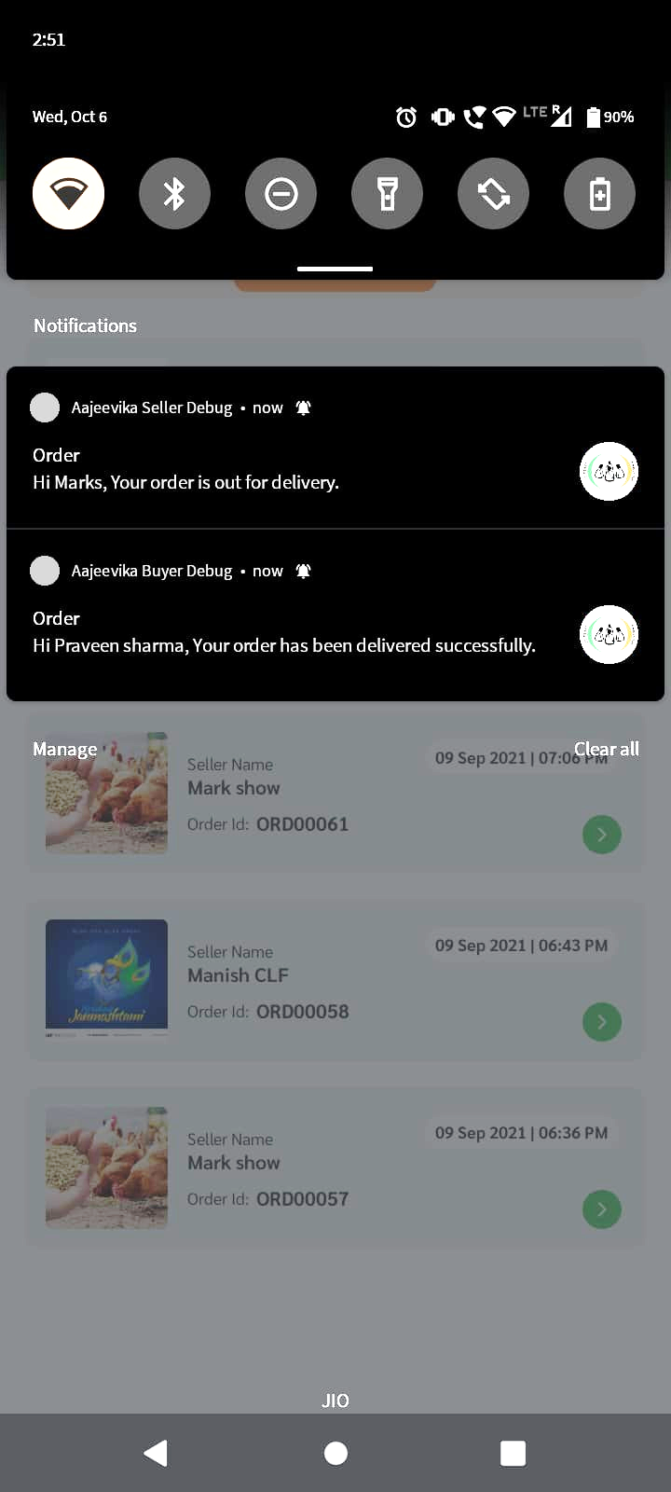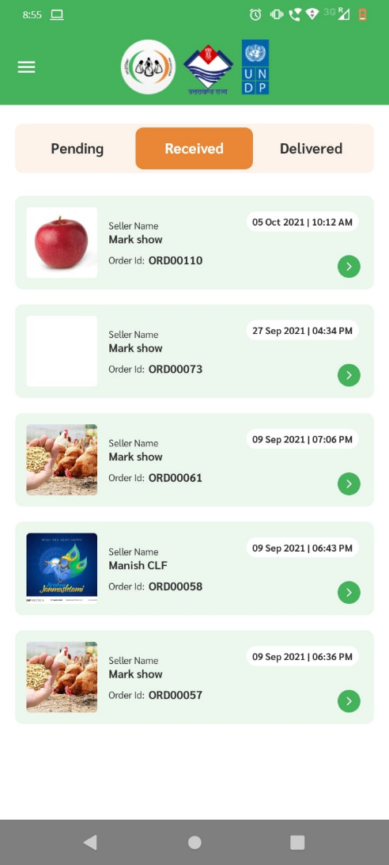

Notification to respective Buyer

Notification to respective Seller

## Delivered Orders

* These are the orders which have been handed over to the buyer by the collection center. The order details can be viewed by clicking on a particular order from the list view.
* You can click on products to view order details.

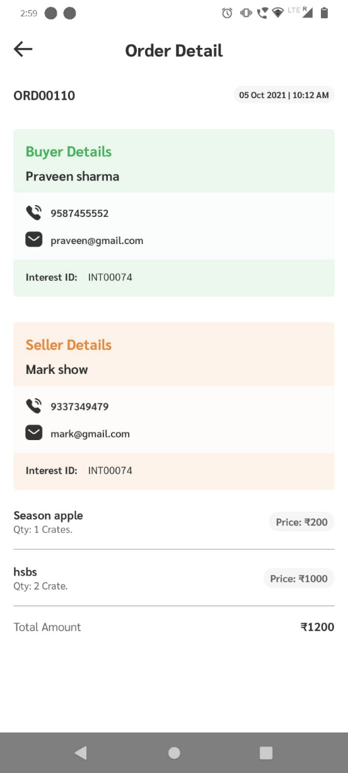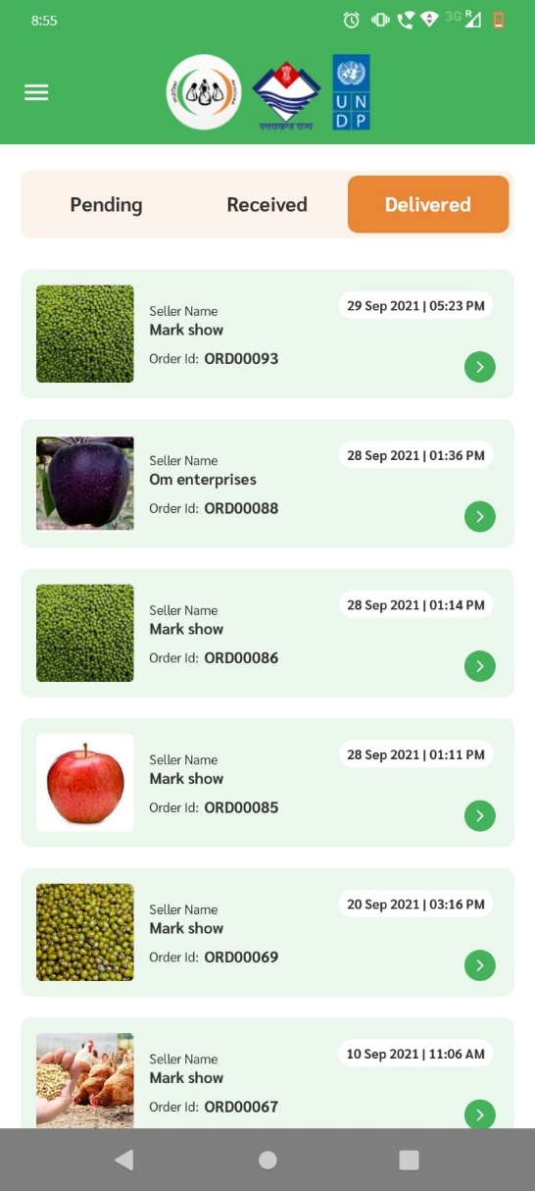

# Section 3: Other features

## Change Language

To change language follow the steps below:

Step 1: Click on menu button on homepage

Step 2: From side-pane click language toggle button.

Now the language of the entire app will change to Hindi.

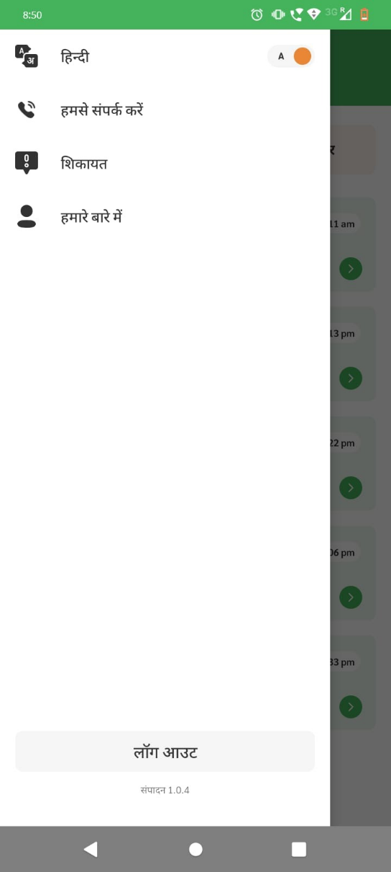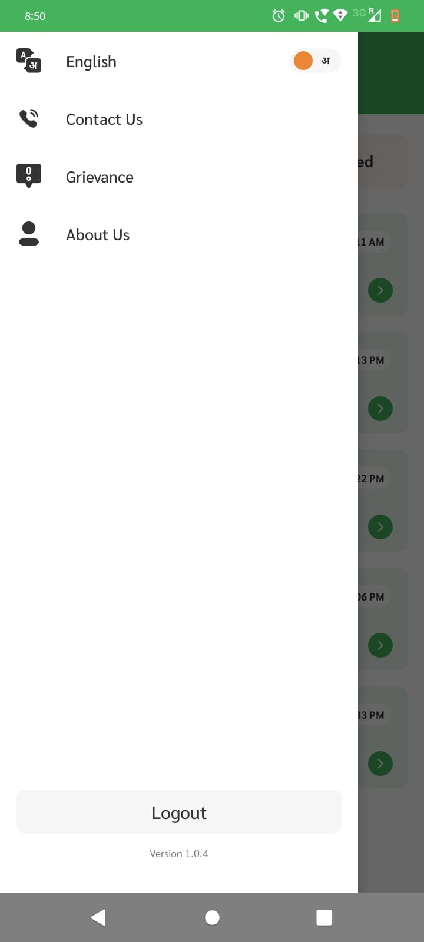

## Grievances

In order to raise an issue users can built in grievances section in the app, In order to access grievances follow the steps below:

Step 1: Go to side pane and click on “Grievances”

Step 2: Click on “Raise Ticket” at the bottom.

Step 3: Select your issue from dropdown, and explain in the text field below

Step 4: Click on “Submit”

